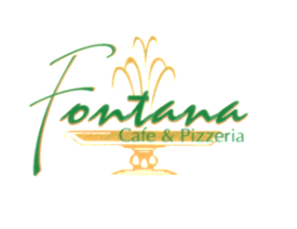
Phone: (856) 321-1301 www.CafeFontana.com
Fax: (856) 321-9448

Off Premises Catering
Choice of: 1 Salads, 1 Pasta, 1 Entrée, Dinner rolls & Butter
Delivery or Pick up - Ready in about Two Hours
Minimum of 10 People
$11.95 Per person (Plus tax)
Salads (choose one)
Tossed Salad / Caesar Salad
Pasta (choose one)
Penne Vodka Rigatoni Marinara
Tortellini Alfredo Cheese Ravioli
Baked Ziti Stuffed Shells
Entrées (choose one)
Chicken Piccante Sausage, Peppers and Onion
Chicken Marsala Eggplant Parmigiana
Chicken Florentine Homemade Meatballs
Chicken Parmigiana Chicken Cacciatore

Additional Salad, Pasta, Or Entrée available for an extra cost of $2 per person!
Set up Racks Available (Includes 1 Steam Pan and 2 Sternos) – $8.00 each
All Deliveries will be charged an additional 10% service fee
Name:_______________________ Telephone:________________ Customers Signature:_______________
Type of Event:_________________ E-mail:___________________ Today’s Date:______________________
Date of Event:_________________ Time:____________________ Deposit Amount:___________________
Number of Adults:_____________ Kids (12 & under):__________ Total for Event:____________________

